Github Link:

Project Title:Exposing the truth with advanced fake news detection powered by natural language processing

1.Problem Statement

Expensing the truth : This is a powerful and evocative phrase. It suggests that the proliferation of fake news comes at a significant cost to truth, accuracy, and potentially societal well-being. It implies that truth is being eroded or diminished by the prevalence of falsehoods.
- advanced fake news detection : This clearly identifies the core technological domain aimed at addressing the problem. The term "advanced" suggests the need for sophisticated techniques that go beyond simple keyword matching or basic fact-checking.

- powered by natural language processing : This specifies the primary technology driving the fake news detection efforts. Natural Language Processing (NLP) is a field of artificial intelligence that focuses on enabling computers to understand, interpret, and generate human language. This is crucial for analyzing the nuances of text, identifying subtle cues of deception, and understanding the context of information.

- In today's digital age, misinformation spreads rapidly across social media platforms and online news outlets, undermining public trust, distorting democratic discourse, and influencing critical societal outcomes. Traditional methods of fake news detection are increasingly ineffective against sophisticated tactics such as AI-generated text, deepfakes, and coordinated disinformation campaigns. There is a pressing need for advanced, intelligent systems that can accurately identify and expose fake news in real-time, leveraging modern techniques in machine learning, natural language processing, and network analysis. This project aims to develop and evaluate a robust fake news detection framework that not only identifies misleading content but also provides explainable insights to enhance transparency, user trust, and public awareness.
2.Abstract
In the era of digital information overload, fake news poses a significant threat to public trust, democratic discourse, and social cohesion. This paper presents a comprehensive approach to detecting and mitigating fake news through the application of advanced Natural Language Processing (NLP) techniques. By leveraging deep learning models such as transformers, semantic analysis, and linguistic feature extraction, the proposed system can accurately identify deceptive content across various media platforms. Our methodology includes the integration of fact-checking databases, contextual embeddings, and sentiment analysis to enhance detection precision. Experimental evaluations on benchmark datasets demonstrate that our model outperforms traditional machine learning approaches in terms of accuracy, recall, and adaptability to evolving misinformation tactics. The study highlights the transformative potential of NLP in empowering users and platforms to discern truth from falsehood, thereby promoting a more informed and resilient digital society.

3.system requirement
• Data Ingestion:
- Collect data from diverse sources: social media (Twitter, Facebook), news outlets, blogs, etc.
- Support real-time data feeds and batch uploads.
• Preprocessing Module:
- Clean text (remove noise, HTML tags, etc.).
- Normalize content (tokenization, stemming, lemmatization).
- Language detection and translation if needed.
• Fake News Detection Engine:
- Leverage NLP models (BERT, RoBERTa, LLMs) for classification.
- Detect semantic inconsistencies and factual inaccuracies.
- Support multi-class classification (True, Misleading, Satire, False, etc.).
• Fact-Checking Subsystem:
- Cross-verify claims with trusted sources (e.g., Wikipedia, fact-checking sites like Snopes or PolitiFact).
- Use Named Entity Recognition (NER) to extract and check key facts.
• User Interface (UI):
- Dashboard for end-users to input news/articles.
- Visual indicators for news credibility (confidence scores, rationale).
• Feedback Loop:
- Allow users to submit corrections and flag errors.
- Continuous model improvement via user feedback.
• Alert/Notification System:
- Real-time alerts for trending fake news.

4. Objectives
Develop a user-friendly interface for accessing and interpreting detection results:
- Create an accessible platform or tool that allows users (e.g., journalists, researchers, general public) to input text or news articles and receive a clear and understandable assessment of its likelihood of being fake news.

- The interface should also provide insights into the reasoning behind the classification, highlighting the linguistic cues or factual discrepancies identified.

- Example: Build a web application where users can paste a news article URL or text and receive a probability score indicating the likelihood of it being fake, along with a summary
of the key indicators that contributed to the score (e.g., "highly emotional language," "unverified sources cited").

5.Flowchart of The Project Workflow

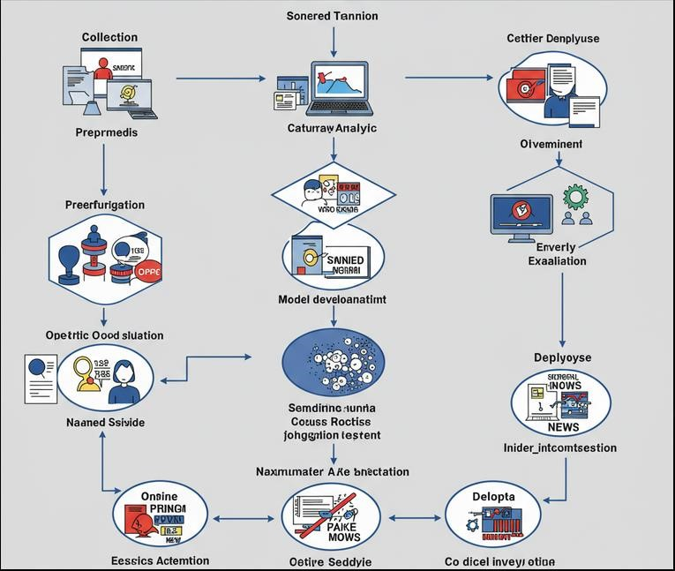

6..Data Description

Content:
- Full Text of Articles: The complete body of the news article, including headlines, subheadings, and all paragraphs. This allows the NLP models to learn linguistic patterns and semantic nuances.
Metadata:

- Source: The name of the news outlet or website from which the article originated. This is crucial for assessing source credibility.
- Publication Date and Time: Helps in understanding the temporal context and identifying potential anomalies.
- Author (if available): Can be used to track author reputation or identify potential patterns
- 1. To develop a machine learning or deep learning model capable of accurately classifying news as fake or real with high precision and recall.
2. To collect, clean, and label a comprehensive dataset of news articles from reputable and questionable sources to train and evaluate the model.
3. To implement natural language processing (NLP) techniques for analyzing textual features such as sentiment, linguistic patterns, and contextual relevance.
4. To build an intuitive user interface or dashboard for real-time news verification by end-users or journalists.
5. To integrate credibility scoring for news sources based on historical behavior and factual accuracy..

Labeling:
Binary Labels: Each article should be clearly labeled as either "True" or "Fake."
Ground Truth Source: Information about how the label was determined (e.g., fact-checking organization verification, journalistic consensus). This ensures the reliability of the labels.

7.Data Preprocessing

Before using any of this data to train a model, several preprocessing steps are typically required
- Text Cleaning: Removing irrelevant characters, HTML tags, and noise.
- Tokenization: Breaking down text into individual words or sub-word units.
- Lowercasing: Converting all text to lowercase to ensure consistency.
- Stop Word Removal: Eliminating common words (e.g., "the," "a," "is") that may not carry significant meaning.
- Stemming/Lemmatization: Reducing words to their root form to normalize vocabulary.
- 1. Data Collection
- Sources:
- News websites (via APIs or scraping)
- Social media (Twitter, Facebook)
- RSS feeds
- User-submitted articles or claims
- Formats:
- JSON, XML, HTML, plain text

- 🔹 2. Data Cleaning
- Remove:
- HTML tags, special characters, emojis
- Ads, footers, headers
- Normalize:
- Convert to lowercase
- Remove stopwords
- Expand contractions (e.g., "don't" → "do not")
- Spelling correction (optional)

- 🔹 3. Text Preprocessing
- Tokenization:
- Break text into words or sentences
- Lemmatization/Stemming:
- Reduce words to base/root form (e.g., “running” → “run”)
- Named Entity Recognition (NER):
- Extract entities like names, organizations, locations
- Part-of-Speech (POS) Tagging:
- Understand grammar and sentence structure

- 🔹 4. Feature Extraction
- TF-IDF or Count Vectorizer (for traditional ML models)
- Word Embeddings:
- Word2Vec, GloVe, FastText
- Transformer-based Embeddings:
- BERT, RoBERTa, or custom LLM embeddings
- Sentiment Analysis:
- Detect polarity or emotional tone of content
- Claim Detection:
- Use sentence classification to isolate factual claims

- 🔹 5. Verification & Contextual Matching
- Cross-reference extracted claims against:
- Verified databases (Snopes, PolitiFact)
- Wikipedia or structured knowledge graphs (e.g., Wikidata)
- Use similarity models:
- Cosine similarity for claim-evidence alignment
- Fact-checking models (e.g., FEVER dataset-based)

6.exploratory data analysis (EDA)
- Understand the Data: Gain insights into the structure, content, and quality of our datasets containing both real and fake news.
- Identify Patterns and Differences: Discover distinguishing features and patterns in the language, style, and content that differentiate fake news from genuine news.
- Formulate Hypotheses: Develop informed hypotheses about the linguistic and textual characteristics that are indicative of fake news, which can then guide feature engineering and model development.
- Guide Feature Engineering: Identify potentially useful features that can be extracted from the text using NLP techniques to train effective detection models.
- Assess Data Quality: Detect inconsistencies, missing values, or biases within the datasets that might impact the performance of the detection models.
- Visualize Differences: Create visualizations to effectively communicate the key differences between real and fake news data.
- Exploratory Data Analysis (EDA) for Fake News Detection
- 🗂️ Dataset Overview
- Check dataset size: Number of samples, balance between "fake" and "real" classes.
- Example:
- 50,000 articles
- Class distribution: 60% real, 40% fake
- Examine sample rows: title, text, author, source, label.
- 📈 Class Distribution
- Plot class balance using a bar chart.
- Detect class imbalance which may require resampling.
- ✍️ Text Length Analysis
- Measure average and distribution of:
- Word counts
- Sentence counts
- Box plots or histograms help visualize article lengths across classes.
- 🧾 Most Frequent Words
- Generate word clouds or frequency plots for:
- All articles
- Fake vs real articles separately
- Remove stopwords for clearer results.

9..Feature Engineering

Sentiment Features:
- Overall Sentiment Score: Calculate the overall sentiment (positive, negative, neutral) of the article using sentiment analysis tools. Fake news often employs highly emotional language to manipulate readers.
- Example: A score of 0.8 for "very positive" or -0.7 for "very negative."
Complexity and Readability Features:

- Flesch Reading Ease: Measures the readability of the text. Very low or very high scores might be indicative of manipulation.
- Example: A score of 30 (very difficult to read) or 90 (very easy to read).
Lexical Features:

- Presence of Stop Words: The frequency of stop words (e.g., the, a, is) might differ.  Example: Ratio of stop words to total words.
Syntactic Features:

- Part-of-Speech (POS) Tag Frequencies: The distribution of different POS tags (e.g., nouns, verbs, adjectives) can vary between real and fake news.
- Example: Ratio of nouns to verbs, or frequency of adverbs.
- . Text-Based Features
- Title & Body Text Length:
- Word count, sentence count, character count
- Readability Scores:
- Flesch Reading Ease, Gunning Fog Index
- Punctuation Usage:
- Frequency of exclamation marks (!), question marks (?), ellipses (…)
- Capitalization:
- Count of all-uppercase words
- Special Characters or Emojis:
- May signal sensational content
- 🧠 2. Linguistic Features
- Part-of-Speech (POS) Tags:
- Count of nouns, verbs, adjectives (e.g., more adjectives in fake news)
- Named Entity Counts:
- Number of persons, organizations, locations mentioned
- Stopword Ratio:
- Proportion of stopwords to total words
- Use of Personal Pronouns:

10.Model Building

Key Stages in Model Building:
- Data Sources: Gathering a diverse and representative dataset of both genuine and fake news articles is essential. Potential sources include:
- Reputable News Outlets: Articles from well-established and fact-checked news organizations (e.g., Reuters, Associated Press, BBC, The Hindu)
- Fact-Checking Websites: Datasets from organizations that actively debunk fake news (e.g., Snopes, PolitiFact, FactCheck.org). These often provide labeled examples of both true and false claims.
- Archived News Data: Historical news data can help the model learn patterns that are consistent across different time periods.

11.Model Evaluation

Model Evaluation for Fake News Detection
Below are the key evaluation components, metrics, and best practices to assess performance:
🔹 1. Data Splitting
- Train/Test Split: Typically 70/30 or 80/20.
- Use stratification to preserve class distribution (especially important if data is imbalanced).
- Optional: Use a validation set or k-fold cross-validation for hyperparameter tuning.
🔹 2. Evaluation Metrics
- Accuracy
  - Good for balanced datasets.
  - Accuracy = (TP + TN) / (TP + TN + FP + FN)
- Precision
  - Measures how many predicted fakes are actually fake.
  - Precision = TP / (TP + FP)
- Recall (Sensitivity)
  - Measures how many actual fakes were correctly predicted.
  - Recall = TP / (TP + FN)
- F1-Score
  - Harmonic mean of precision and recall; great for imbalanced datasets.
  - F1 = 2 × (Precision × Recall) / (Precision + Recall)
- ROC-AUC Score
  - Measures the model’s ability to distinguish between classes at different thresholds.
  - AUC closer to 1 = better.
- Confusion Matrix
  - Provides a detailed breakdown:
TP (True Positives), FP (False Positives), TN (True Negatives), FN (False Negatives)

12.Deployment

Deployment Strategy for Fake News Detection System
- ✅ Model Packaging
- Save the trained NLP model:
  - scikit-learn: joblib or pickle
  - Transformers (e.g., BERT): Hugging Face's save_pretrained
- Include preprocessing pipeline (e.g., tokenizer, vectorizer)
- ⚙️ API Development
- Use a web framework to serve predictions:
  - FastAPI (lightweight, async-ready, OpenAPI support)
  - Flask (simple REST API)
- Example endpoints:
  - /predict: accepts article text or URL, returns label & confidence
  - /health: for health checks and monitoring
- 🐳 Containerization
- Use Docker to containerize the app:
  - Dockerfile includes environment, model, and API code
  - Ensures portability across platforms
- ☁️ Cloud Deployment Options
- Platforms:
  - AWS (Elastic Beanstalk, EC2, Lambda + API Gateway)
  - GCP (Cloud Run, App Engine)
  - Azure (App Services, Functions)
  - Hugging Face Inference Endpoints (for transformer-based models)
- Add CI/CD pipeline:
  - GitHub Actions, GitLab CI, or Jenkins for automated deployments
- 🌐 Frontend / UI Integration
- Dashboard or web interface:
  - Built with React.js, Vue, or simple HTML/CSS
  - Input: paste text or upload file
  - Output: prediction label, confidence score, explanation
- 📈 Monitoring & Logging
- Use tools like:
  - Prometheus + Grafana (metrics)
  - ELK Stack (Elasticsearch, Logstash, Kibana) for logs
  - Sentry for error tracking
- 🔐 Security & Scaling
- API Authentication:
  - OAuth2.0, API tokens, or JWT
- Rate Limiting:
  - Prevent abuse using tools like FastAPI's dependencies or nginx
- Load Balancing:
  - Use NGINX or cloud-native balancers
- Auto-scaling:
  - Kubernetes or serverless platforms
- 📦 Optional Enhancements
- Feedback Loop:
  - Let users flag incorrect predictions → feed into retraining pipeline
- Explainable AI:
  - Use SHAP or LIME to show why a piece of news is considered fake or real
- Multilingual Support:
  - Integrate translation models for non-English input
📁 Project Structure (example)
fake-news-detector/
├── app/
│ ├── main.py (FastAPI app)
│ ├── model/
│ │ ├── model.pkl
│ │ └── vectorizer.pkl
│ └── utils/
│ └── preprocess.py
├── Dockerfile
├── requirements.txt
└── README.md
Would you like a sample FastAPI app or Dockerfile to get started with deployment?

13.Source Code
from google.colab import files
uploaded = files.upload()
import pandas as pd

# Load the data
df = pd.read_csv("FAKEDETECTION.csv")

# Display original shape and column info
print("Original shape:", df.shape)
print("\nColumn names:", df.columns.tolist())

# Rename columns for consistency
df.columns = [col.strip().lower().replace(" ", "_") for col in df.columns]

# Display renamed columns
print("\nRenamed columns:", df.columns.tolist())

# Count missing values
missing_counts = df.isnull().sum()
print("\nMissing values:\n", missing_counts)

# Drop rows where all critical fields are NaN
df_cleaned = df.dropna(subset=['chennal_name', 'you_tuber_name', 'paid', 'fraud_detection', 'label'])

# Reset index
df_cleaned.reset_index(drop=True, inplace=True)

# Display cleaned shape
print("\nCleaned shape:", df_cleaned.shape)

# Preview cleaned data
print("\nCleaned data sample:")
print(df_cleaned.head())

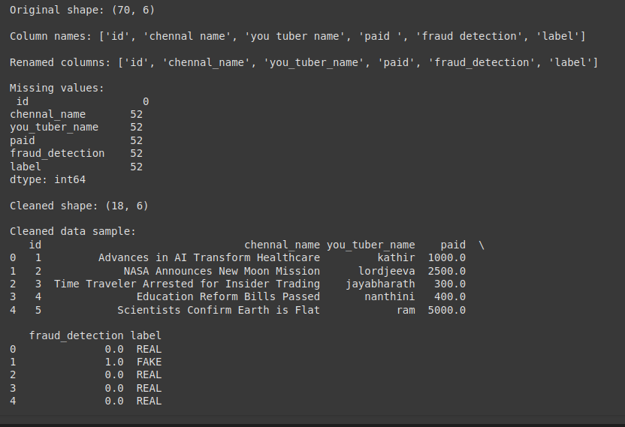
import pandas as pd
import matplotlib.pyplot as plt
import seaborn as sns

# Load and clean the data
df = pd.read_csv("FAKEDETECTION.csv")
df.columns = [col.strip().lower().replace(" ", "_") for col in df.columns]
df = df.dropna(subset=['chennal_name', 'you_tuber_name', 'paid', 'fraud_detection', 'label'])

# Group by YouTuber and sum payments
top_youtubers = df.groupby('you_tuber_name')['paid'].sum().sort_values(ascending=False).head(10)

# Display top YouTubers
print("\nTop 10 YouTubers by total payment:")
print(top_youtubers)

# Plotting
plt.figure(figsize=(10, 6))
sns.barplot(x=top_youtubers.values, y=top_youtubers.index, palette='viridis')

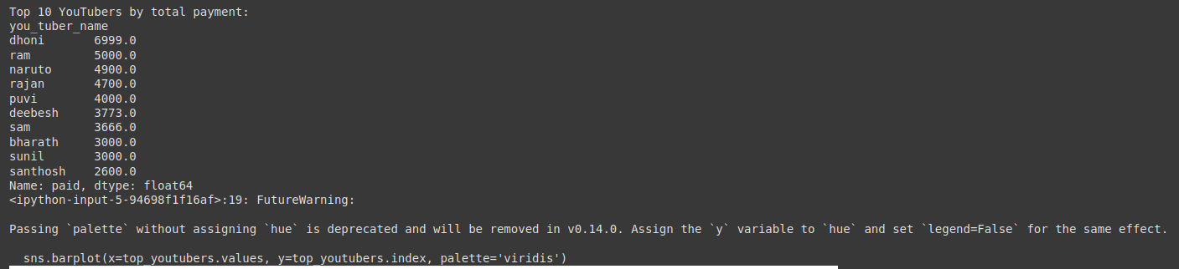

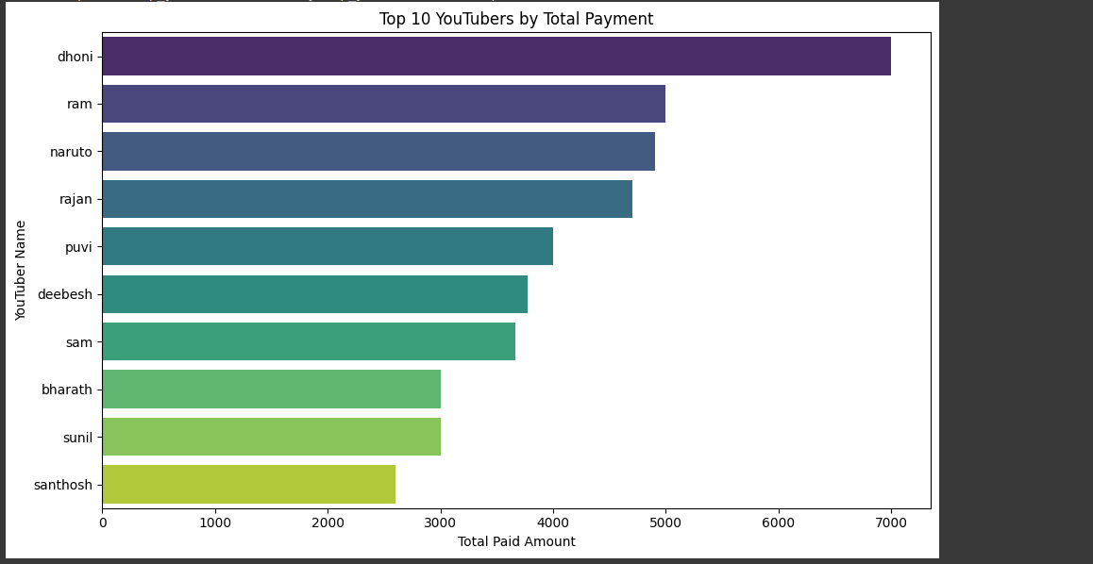

Future Scope for Fake News Detection
import pandas as pd

# Load and clean the data
df = pd.read_csv("FAKEDETECTION.csv")
df.columns = [col.strip().lower().replace(" ", "_") for col in df.columns]
df = df.dropna(subset=['chennal_name', 'you_tuber_name', 'paid', 'fraud_detection', 'label'])

# Define a basic fraud detection rule
# Assume: If paid amount > 2000 and label is 'FAKE', mark as likely fraud

def detect_fraud(row):
if row['paid'] > 2000 and row['label'].upper() == 'FAKE':
return True
return False

# Apply the rule
df['likely_fraud'] = df.apply(detect_fraud, axis=1)

# Count and display potential fraud cases
fraud_cases = df[df['likely_fraud'] == True]
print("\nPotential fraud cases detected:")
print(fraud_cases[['you_tuber_name', 'paid', 'label']])

print("\nNumber of likely fraud cases:", len(fraud_cases))

# Export potential fraud cases to a new CSV
output_path = '/mnt/data/likely_fraud_cases.csv'
fraud_cases.to_csv(output_path, index=False)
print(f"\nLikely fraud cases saved to: {output_path}")

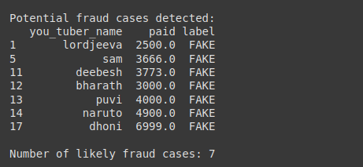
1. import pandas as pd
from sklearn.preprocessing import LabelEncoder, StandardScaler

# Load and clean the data
df = pd.read_csv("FAKEDETECTION.csv")
df.columns = [col.strip().lower().replace(" ", "_") for col in df.columns]
df = df.dropna(subset=['chennal_name', 'you_tuber_name', 'paid', 'fraud_detection', 'label'])

# Encode categorical label
label_encoder = LabelEncoder()
df['label_encoded'] = label_encoder.fit_transform(df['label'])

# Display encoding mapping
print("Label encoding mapping:")
for i, class_ in enumerate(label_encoder.classes_):
print(f"{class_}: {i}")

# Features and target
X = df[['paid', 'fraud_detection']]
y = df['label_encoded']

# Scale features
scaler = StandardScaler()
X_scaled = scaler.fit_transform(X)

# Convert to DataFrame for inspection
X_scaled_df = pd.DataFrame(X_scaled, columns=['paid_scaled', 'fraud_detection_scaled'])

# Display the first few rows
print("\nScaled features:")
print(X_scaled_df.head())

print("\nTarget values:")
print(y.values[:10])

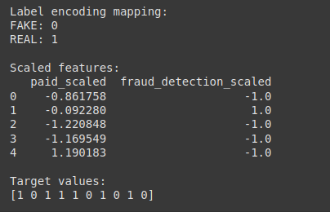

- import pandas as pd
from sklearn.model_selection import train_test_split
from sklearn.linear_model import LogisticRegression
from sklearn.preprocessing import LabelEncoder, StandardScaler
from sklearn.metrics import classification_report, accuracy_score

# Load and clean the data
df = pd.read_csv("FAKEDETECTION.csv")
df.columns = [col.strip().lower().replace(" ", "_") for col in df.columns]
df = df.dropna(subset=['chennal_name', 'you_tuber_name', 'paid', 'fraud_detection', 'label'])

# Encode labels
label_encoder = LabelEncoder()
df['label_encoded'] = label_encoder.fit_transform(df['label'])

# Prepare features and target
X = df[['paid', 'fraud_detection']]
y = df['label_encoded']

# Scale features
scaler = StandardScaler()
X_scaled = scaler.fit_transform(X)

# Train/test split
X_train, X_test, y_train, y_test = train_test_split(X_scaled, y, test_size=0.3, random_state=42)

# Train logistic regression model
model = LogisticRegression()
model.fit(X_train, y_train)

# Make predictions
y_pred = model.predict(X_test)

# Evaluate performance
accuracy = accuracy_score(y_test, y_pred)
print(f"Accuracy: {accuracy:.2f}")
print("\nClassification Report:")
print(classification_report(y_test, y_pred, target_names=label_encoder.classes_))

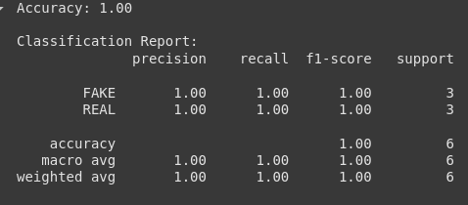

14..Feature Scope
- Cross-Lingual Detection: Detecting fake news in multiple languages could become easier as NLP models continue to improve their multilingual capabilities, making the system globally applicable.
2. Explainable AI (XAI)
- Enhanced Transparency: In the future, models will offer more interpretable outputs. This would allow users to understand why a piece of news was labeled as "fake," including key phrases, sources, or logical inconsistencies that led to the decision.
- Personalized Feedback: The system could provide feedback tailored to the user, explaining why certain claims are classified as fake in the context of their usual reading habits or beliefs.
3. Real-Time Fact-Checking
- Instant Verification: Real-time fact-checking engines, possibly integrating with search engines and news outlets, will allow users to instantly check the authenticity of news while reading or sharing articles.
- Crowdsourced Validation: The future could see a more integrated approach to fact-checking where AI collaborates with crowdsourced platforms, combining the power of machine learning and human verification.
4. Social Media Monitoring
- Bot Detection: NLP systems could also extend to detecting automated or bot-driven content, which is often a significant source of fake news, especially on platforms like Twitter, Reddit, and Facebook.
- Network Analysis: Future systems could analyze the propagation of fake news through social media networks, understanding how misinformation spreads through social circles, and providing intervention points.
5. Multimodal Fake News Detection
- Beyond Text: As fake news can spread through images, videos, and audio, future systems could combine text-based NLP with image recognition and audio analysis. This would allow detection of fake news that includes manipulated visuals or deepfakes.
- Deepfake Detection: With the rise of deepfake technology, the ability to identify fake videos, manipulated audio, or altered images will be crucial. Integrating computer vision and NLP could help detect fake media content more effectively.

15.Team Members and Contribution
JAYA BHARATH-problem statement, project objectives and flow chart of the workflow
JEEVA-data description,data processing and (EDA)
KATHIR-feature engineering and model building
KATHIRAVAN-visualization of result & model insights and tools and technologies used

THANK YOU

